Question set for Place

1. What 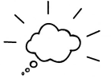   the place?
2. What  do people have about the place?
3. What common 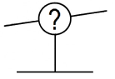 do people make about the FRONTIER?
4. Where did the  for the place 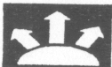?
5. What type of DIVERSITY was present during the time of the FRONTIER?
6. What  were incorporated in the creation of the FRONTIER?
7. What  are still present about the FRONTIER?
8. What changes have  the FRONTIER?
9. What ODYSSEY have people experienced in  the FRONTIER?
10. What SYSTEMS and 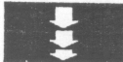 to the creation of the FRONTIER?
11. What was the  for the creation of the ?
12. What   the into reality?
13. What  was used during the era of the FRONTIER?
14. What 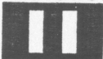 does the FRONTIER share with other places at the time?
15. What  and  went into the creation of the FRONTIER?
16. How did DIVERSITY  the FRONTIER?
17. What are the  that initiated the FRONTIER?
18. How did the FRONTIER  other SYSTEMS and ?
19. What SYSTEMS and  about the FRONTIER  El Paso?
20. What  exists about the  on El Paso?
21. What is  about this place?
22. What DIVERSITY does this place have?
23. Which  have  the place?
24. What  to the  of the place?
25. What  does this place have to other places in El Paso?